**TOPIC: Dimensional Modeling and Schemas**

   1. Design a star schema for a university database, including a fact table for student enrollments and dimension tables for students, courses, and time. Implement the schema using a database of your choice.

   2. Write SQL queries to retrieve data from the star schema, including aggregations and joins between the fact table and dimension tables.

**Star schema for a university database**

Courses(Dim)

Time_id

Am_pm_indicator

Enrollment_id

Student_id

Course_id

Time_id

Enrollment_date

Student_enrollments(Fact)

Time(Dim)

Course_id

Course_name

Course_duration

Course_fees

Course_details

Students(Dim)

Student_id

Student_gender

Student_DOB

Student_firstname

Student_lastname

Output of Students(Dim)

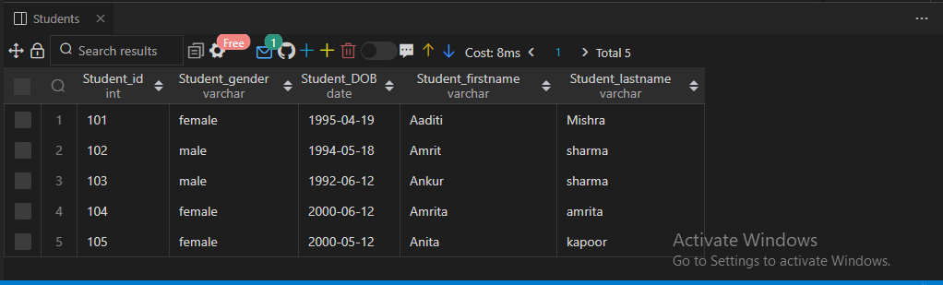

Output of Courses(Dim)

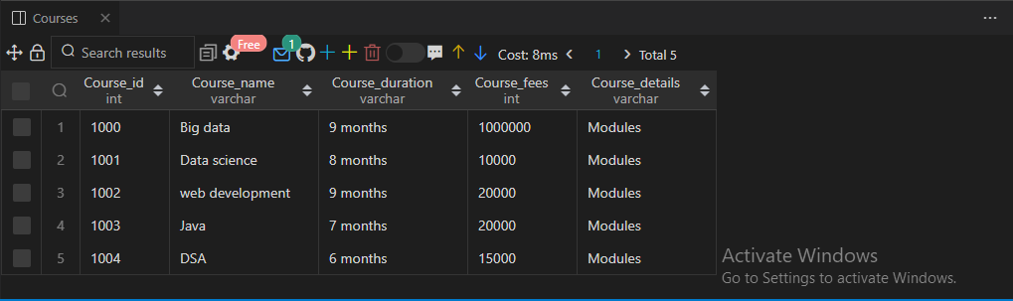

Output of Time(Dim)

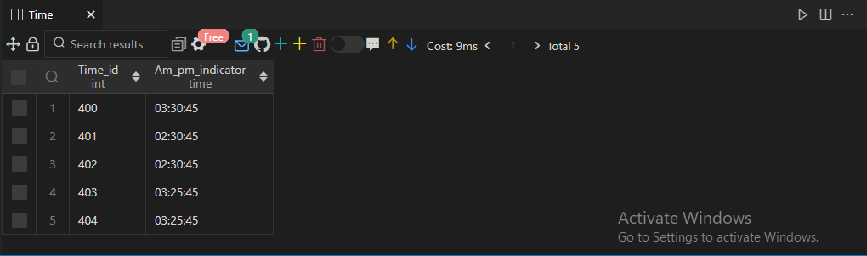

Output of Student_enrollment(Fact)

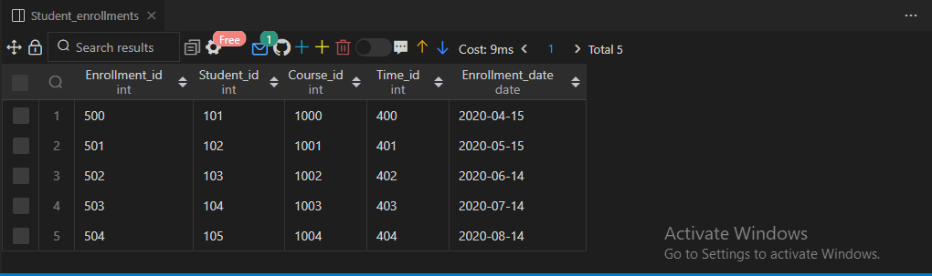

2. Write SQL queries to retrieve data from the star schema, including aggregations and joins between the fact table and dimension tables.

Solutions:- SQL Queries

1. Output

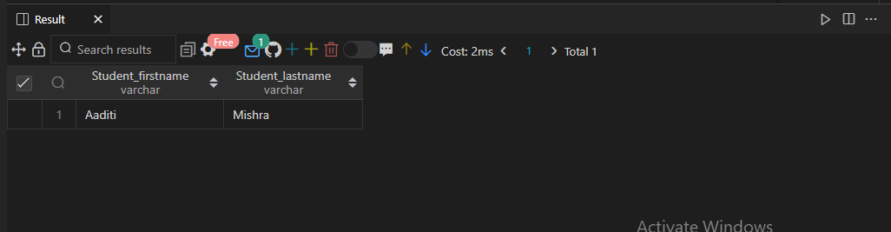

1. Output

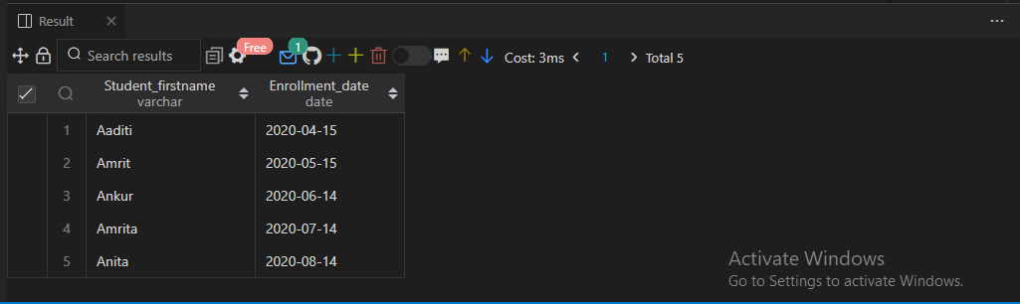

1. Output

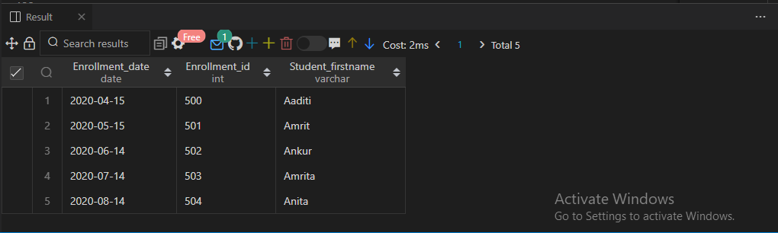

1. Output

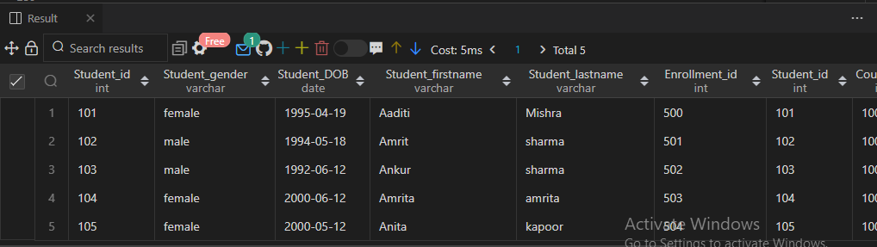

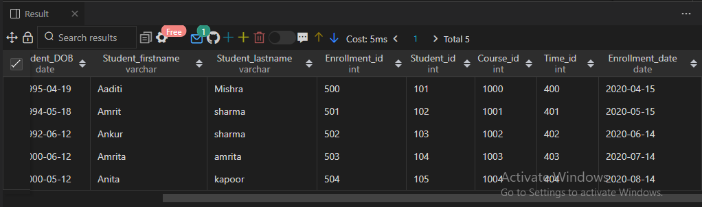

1. Output

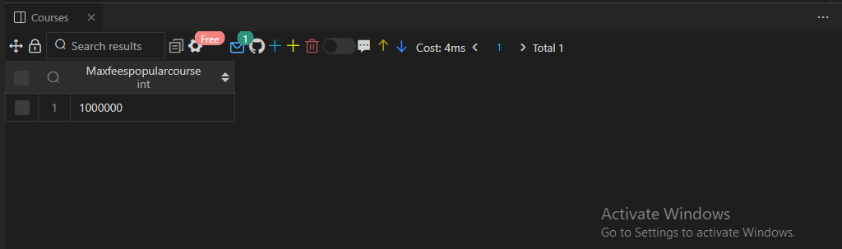

1. Output



1. Output

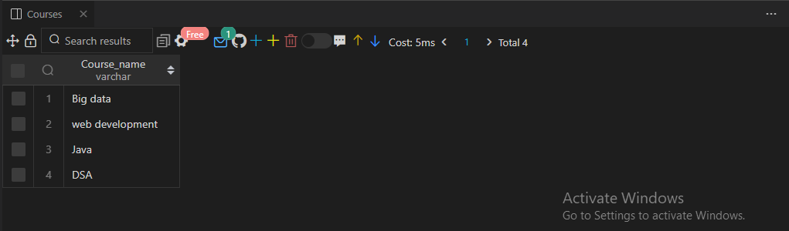

**TOPIC: Data Warehousing Fundamentals**

   1. Design a data warehouse schema for a retail company that includes dimension tables for products, customers, and time. Implement the schema using a relational database management system (RDBMS) of your choice.

   2. Create a fact table that captures sales data, including product ID, customer ID, date, and sales amount. Populate the fact table with sample data.

   3. Write SQL queries to retrieve sales data from the data warehouse, including aggregations and filtering based on different dimensions.

Star schema for a retail company

Customers(Dim)

Products(Dim)

Customer_ID

Customer_payment_method

purchased_item_name

Purchased_item_Quantity

Product_ID

Product_Price

Product_manufacture_date

Product_expiry_date

Sales_data(Fact)

Sales_ID

Product_ID

Customer_ID

Time_ID

date

Sales_amount

Time_ID

Opening_time

Closing_time

Time(Dim)

**Output of table Products(Dim)**

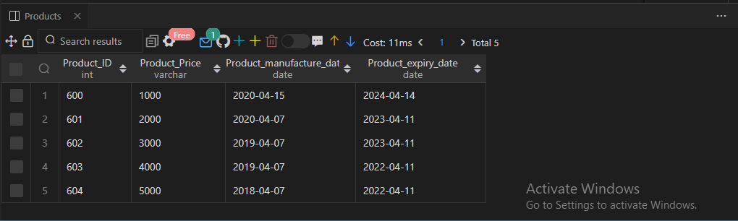

**Output of table Customers**

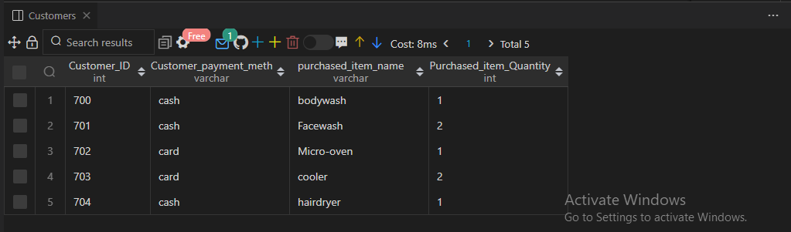

Output of table Time

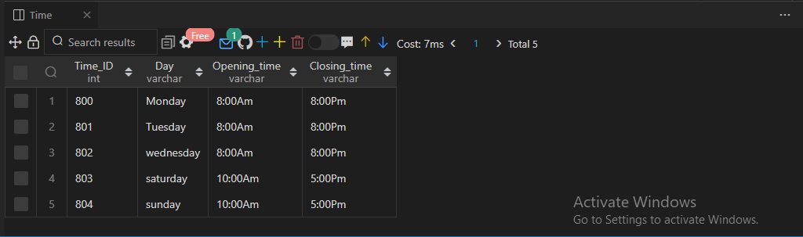

Output of table Sales_data

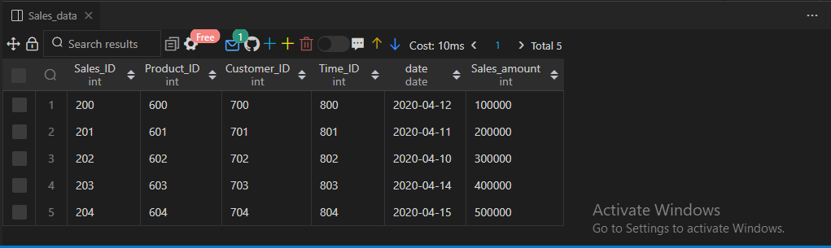

   3. Write SQL queries to retrieve sales data from the data warehouse, including aggregations and filtering based on different dimensions.

1. Output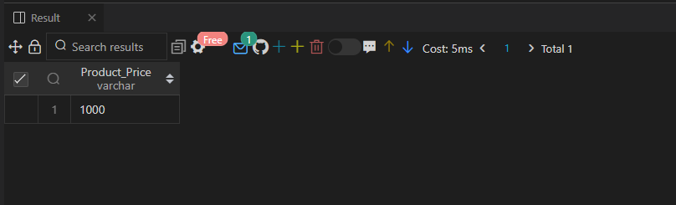

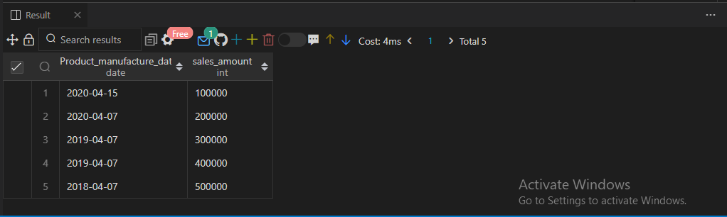

C)

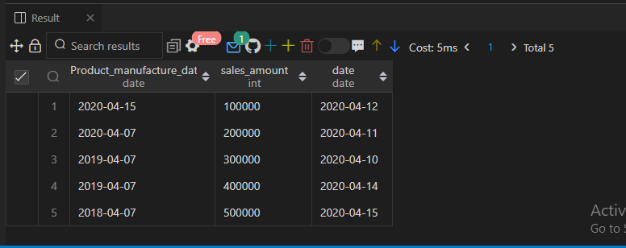

D)

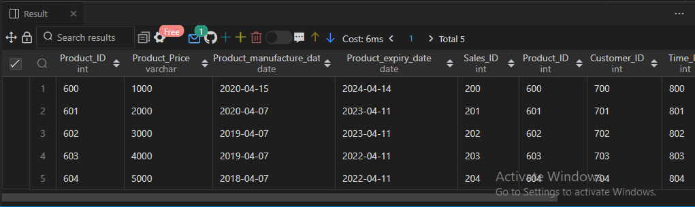

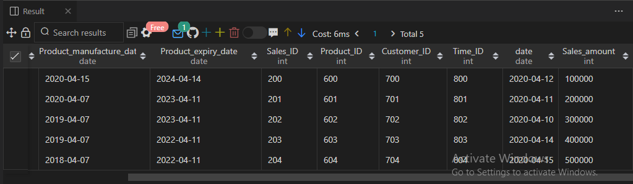

E)

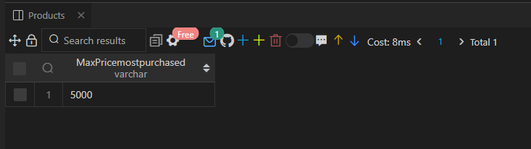

F)

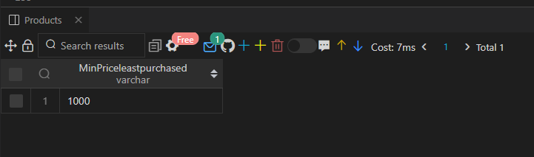

G)

